Voyage Vista: Illuminating Insights from Uber Expeditionary Analysis

1. INTRODUCTION
   1. OVERVIEW

Uber is a multinational transportation network company that operates a ride-hailing platform. It was founded in 2009 by Garrett Camp and Travis Kalanick and is based in San Francisco, California. Uber provides a convenient way for individuals to request rides from drivers who use their own personal vehicles.

Uber Driver Analysis refers to the Analyzing the number of trips taken by Uber drivers can provide insights into their overall activity and the demand for rides in specific areas. Daily, Weekly, or Monthly Analysis: Uber's data can be analyzed on a daily, weekly, monthly basis to understand the trends and patterns of trip volumes. This analysis can help identify peak hours or days of high demand and optimize driver availability during those times. Trips can be analyzed based on geographic regions or specific cities to identify areas with higher demand. This analysis can help Uber drivers decide where to focus their driving efforts for maximum efficiency and profitability.

The Major of our project is to use data Analyzing techniques to find unknown patterns in the Uber Drives dataset. The research is carried out on Uber drives data collected from the year 2016.

1.2 PURPOSE

Key Takeaways. Ride-sharing services like Uber have disrupted the taxi and limo industry, Uber has become a prime example of the gig economy at work. Uber's advantages include door-to-door convenience, safety, and reliable quality.

2.PROBLEM DEFINITION AND DESIGN THINKING

2.1.EMPATHY MAP

* 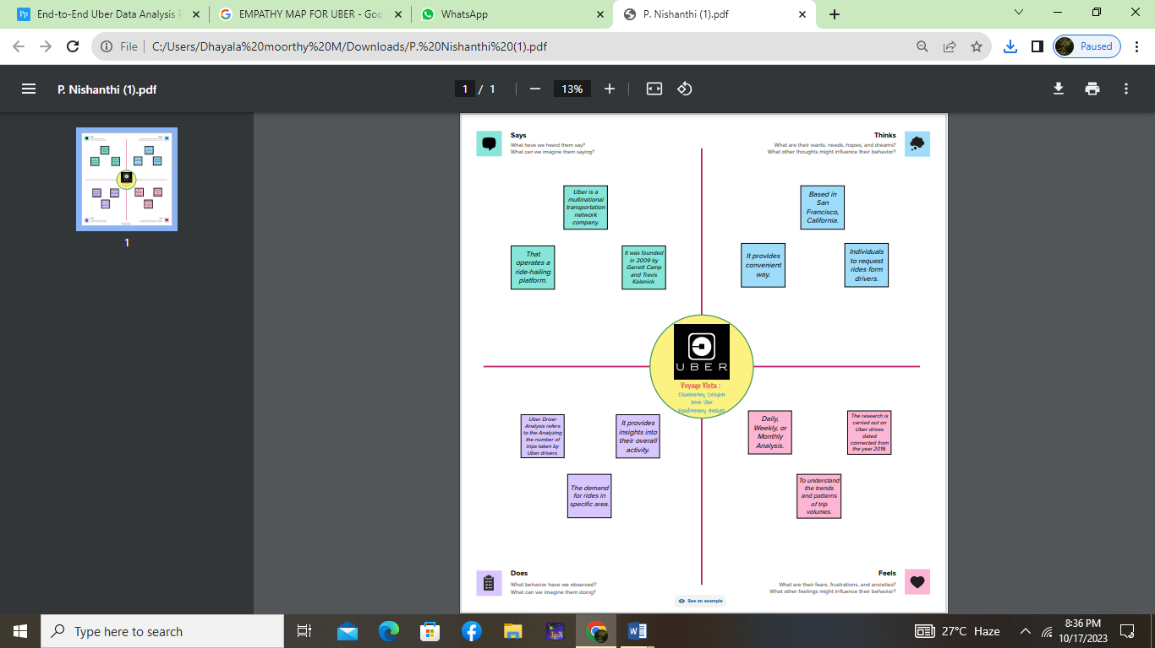

2.2.IDEATION AND BRAINSTORMING MAP

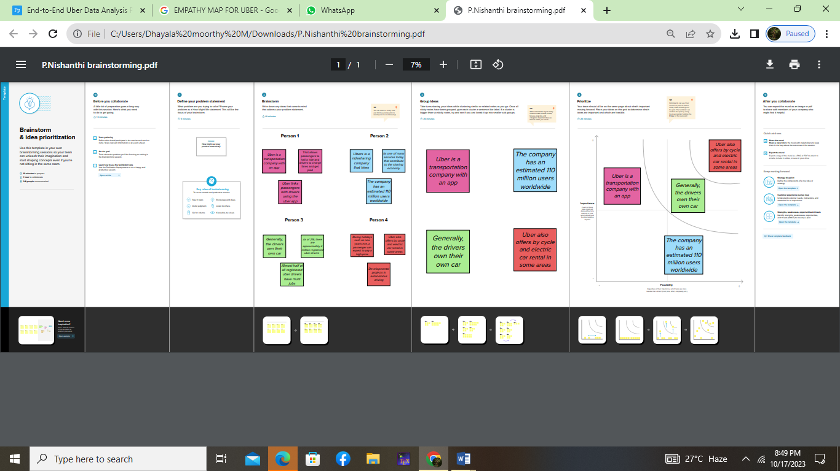

RESULT

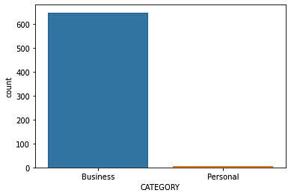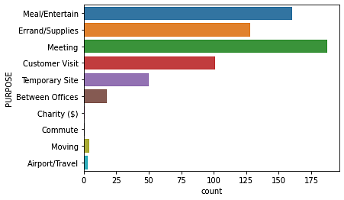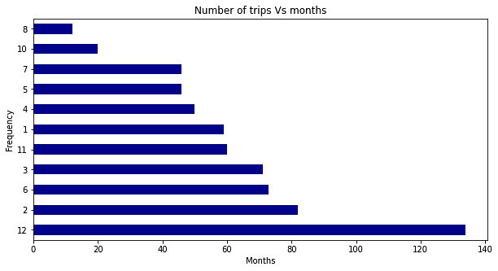

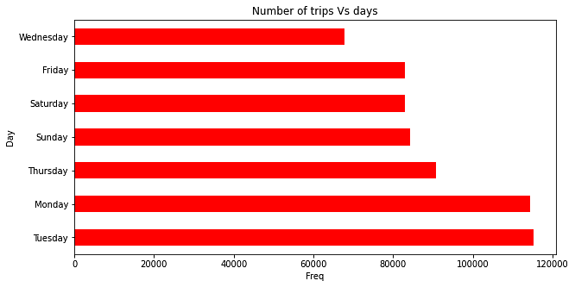

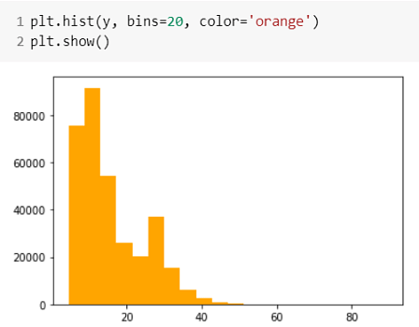

4. ADVANTAGES AND DISADVANTAGES

ADVANTAGES

Uber through E-hail has hired drivers easily and fast. Proprietary software in the app locates drivers circling nearby cheapest carpooling luxury wheels. The price is fixed.

* **Convenient and Cashless**

Instead of chasing a taxi on a street, or calling and waiting, app users can book a ride from any location and it arrives in minutes.

Passenger’s credit or debit card is linked to the taxi app account, no cash changes hands.

After the completion of the ride, A receipt is sent via email, and some links to options for rating and tipping the driver.

* **Professional Service**

Drivers for Uber may use their own cars and bike. Drivers get incentives to keep their taxis clean and well-maintained.

The cheapest options for taxis are late-model compact cars and bikes.

The riders need to insert their destinations into the app, and the drivers use the taxi app navigational features to reach the rider which is provided by the taxi app development company.

The driver talks in a polite and well-spoken manner. Drivers don't get your destination details before picking you up

* **Competitive Pricing**

Uber is less expensive than other taxi services, but not always. Longer trips are always cheaper by Uber but short rides can be expensive.

The price model for Uber and other taxi apps can have higher booking prices due to busy times of the day. It is impossible to come up with a fixed price for an uber ride. Its costing plans vary from one city to another and from one country to another. But uber always show you the estimated fare before starting the ride.

Disadvantages

Drivers are not assured of minimum pay to maintain their own vehicles. This topic is growing controversial in many cities because New York City mandated a $17.22 minimum wage for drivers.

* **Surge Pricing**

“Surge pricing” or “rush time pricing” is not fixed in uber. It’s a free market principle of raising prices according to supply and demand.

This means how many taxis are available (supply) and how many customers want to ride(demand).

This automated system sometimes shows differences in pricing between any two same points.

At peak times, the price could be double or more. This means too costly during rush hour.

Although this benefits uber by increasing the supply of drivers. Drivers can be motivated to earn at this time.

* **Low Fares WorryDrivers**

Some Uber drivers say they struggle to earn minimum wage. Drivers have to pay the cost of fuel, maintenance, and repairs from their own pocket.With competition from other taxi apps, the earnings of drivers can be

* **Price Competition**

Uber and other taxi-hailing companies are engaged in an intensive fight to provide the most affordable service.They are competing with traditional taxi services for both customers and drivers. This has led to low earnings for taxi drivers.

6. CONCLUSION

The three factors that we have discussed have played a role in Über’s rapid ascension are its safety standards, customer service and marketing schemes. These are the things that give Uber a competitive advantage. The reason why Uber is so promising is not merely because they threaten to undermine the existing order, but because they can reduce the scope of regulation. They can do this by solving the problems that markets have had in ensuring that information flows, and people live up to their promises. Further, and most importantly, they can foster the competition that is needed to get the most out of taxi markets. Uber have taken the pre-existing concept of taxiing people and improved and modelled it suit the world as it is today. Their competitive advantage lies in their simplicity and ease of use

7.FUTURE SCOPE

The current world is witnessing many advancements and a lot of startups are evolving rigorously in the world for the past few years. All because of the emergence of on-demand ideas in the current business world with a lot of opportunities. The on-demand apps assist you to order or book anything from anywhere.The on-demand business also aids many [startups to earn more profits](https://www.mindxmaster.com/top-5-ways-to-start-the-engineering-startup-and-get-good-profit-quickly/). Even more traditional businesses have adopted on-demand business to increase their profits tremendously.

THE END